**'Dainik Jagran' dated 17.5.2015**

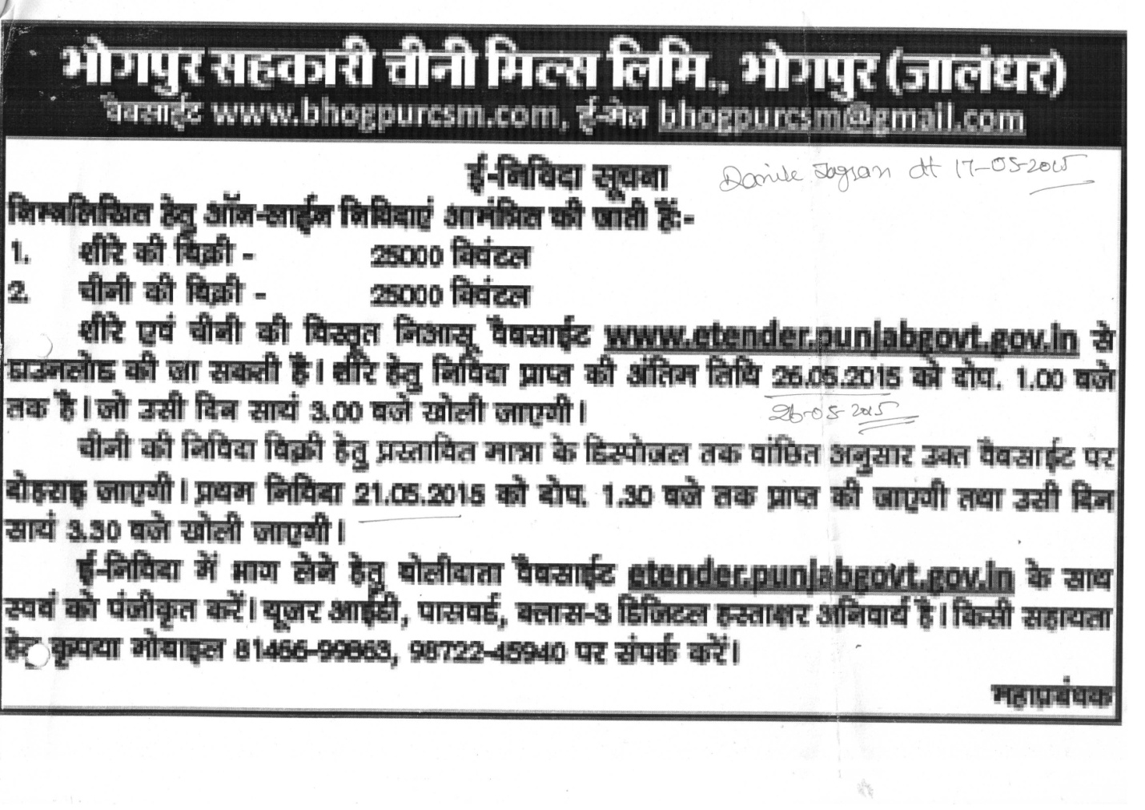

**DAILY AJIT dated 17.5.2015**

